Interaction Design Paper

Itamar Oren-Naftalovich

# PART 1

## Data Relationship #1: Contributor-Ladder Progression Flow

Counts of contributors as they advance from first PR through maintainer status over time.

### Chart A – Stacked Area (Cohort Flow)

Before interaction:

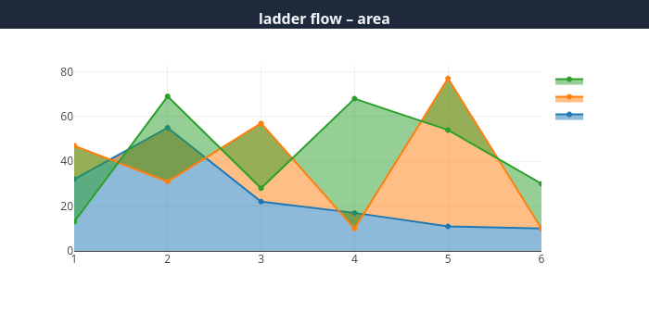

After interaction:

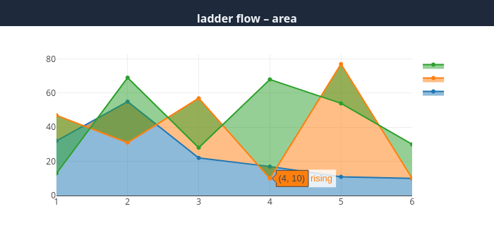

### Chart B – Line / Slope Chart

Before interaction:

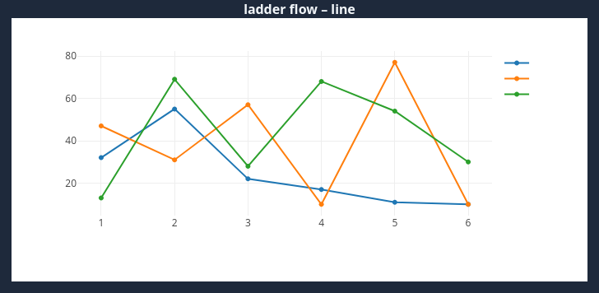

After interaction:

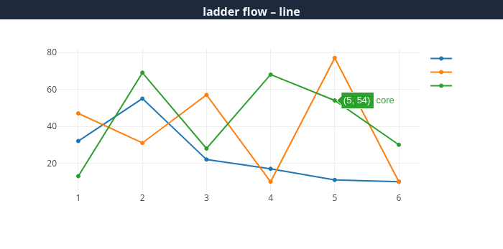

### DISCUSSION

Chart A

Interaction: Brush or hover to isolate a cohort; clicking a stage highlights contributors currently at that ladder rung.

Strengths: Conveys overall retention and growth visually; intuitive sense of volume across stages.

Weaknesses: Exact quantities for small cohorts are hard to read; color stacking can obscure minor flows.

Chart B

Interaction: Hover reveals precise counts per ladder stage; toggle lines in legend.

Strengths: Precise and uncluttered view of trends for each stage.

Weaknesses: Does not communicate inter‑stage flow; users must mentally map transitions.

Indicate which chart works best and why: Chart A offers the strongest storytelling of progression because the stacked area makes retention and drop‑off visually immediate.

## Data Relationship #2: Network Centrality vs. Role Rank

Node degree and betweenness centrality plotted against contributor role hierarchy.

### Chart A – Scatter Plot

Before interaction:

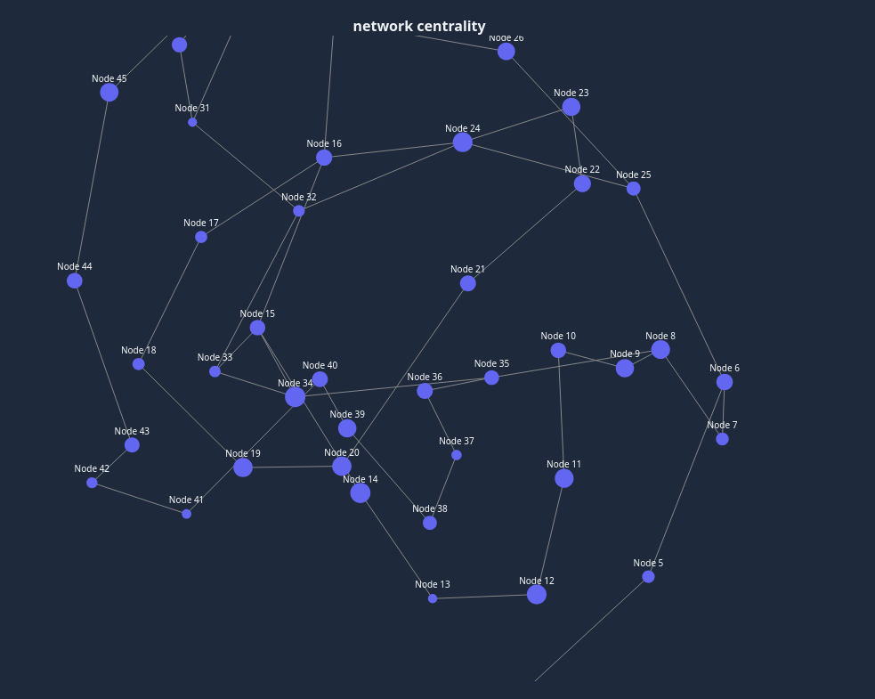

After interaction:

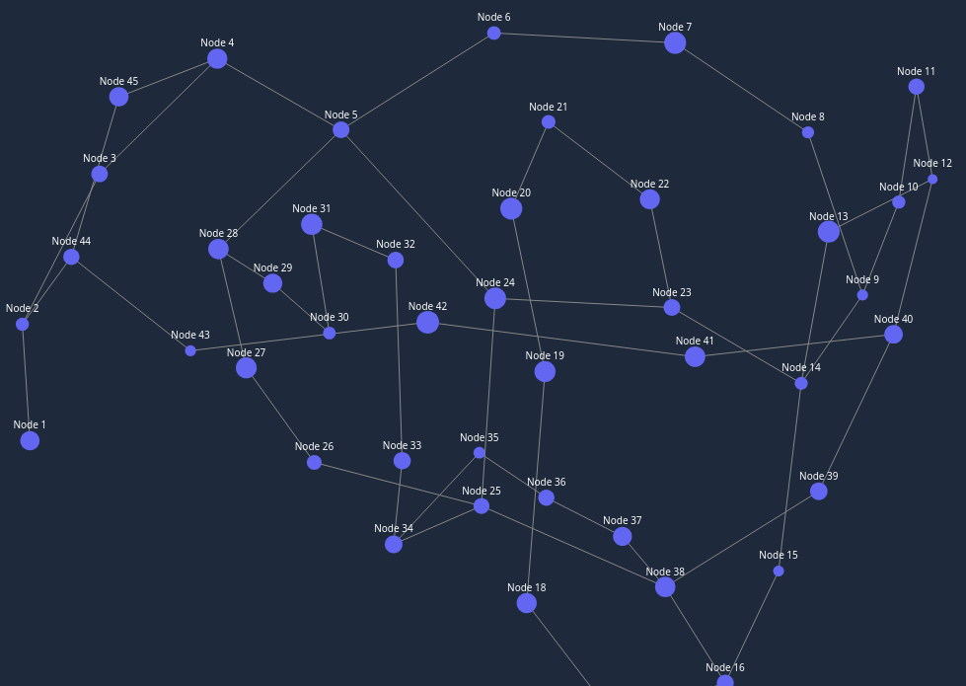

### Chart B – Centrality Scores Bar Chart

Before interaction:

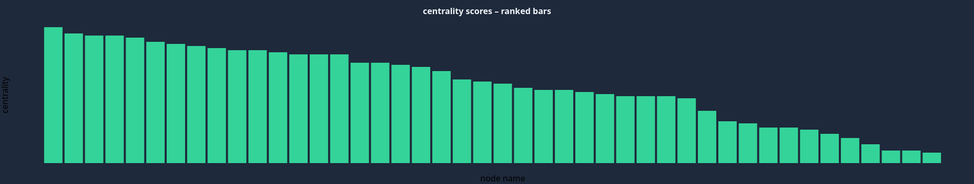

After interaction:

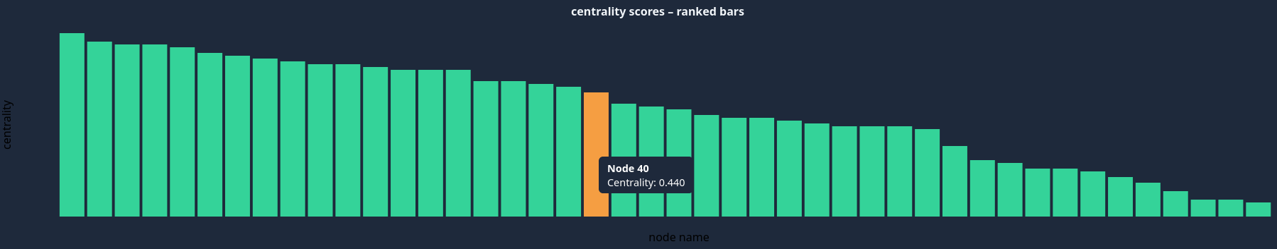

### DISCUSSION

Chart A

Interaction: Hover a point to reveal contributor details; lasso‑select to filter side panel.

Strengths: Highlights outliers and overlap between roles; spatial distribution is intuitive.

Weaknesses: Dense clusters can overlap; color saturation needed for accessibility.

Chart B

Interaction: Click bar to drill down to individual contributors within that score bucket.

Strengths: Rank‑ordered view is compact; easy comparison of aggregate scores.

Weaknesses: Aggregation hides role‑specific variance; less engaging than spatial scatter.

Indicate which chart works best and why: Chart A is superior because it preserves individual granularity and visually surfaces outliers critical to governance decisions.

## Data Relationship #3: Geographic Diversity Over Time

Contributors per region across months.

### Chart A – Stacked Area by Region

Before interaction:

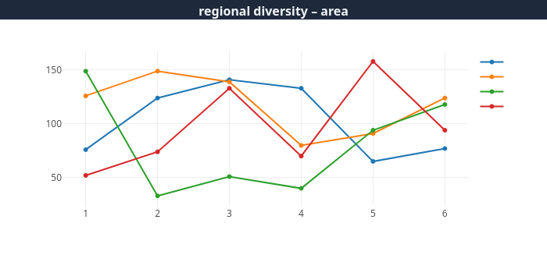

After interaction:

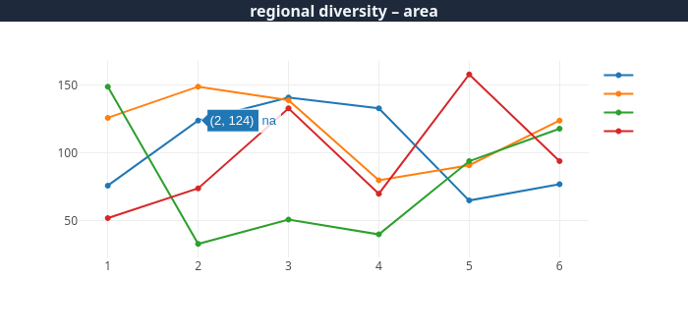

### Chart B – Stacked Bars Snapshot

Before interaction:

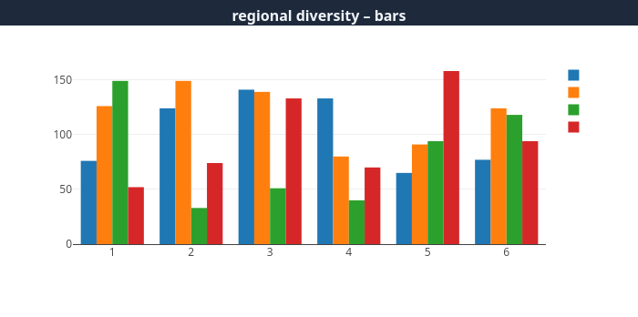

After interaction:

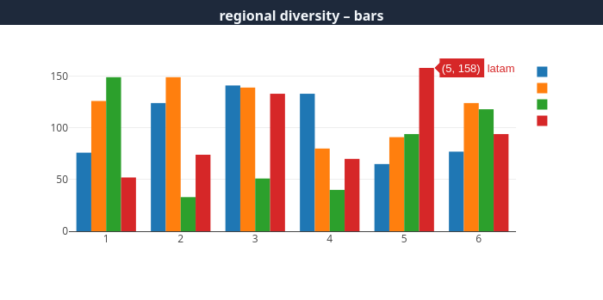

### DISCUSSION

Chart A

Interaction: Hover slice to show absolute and % share; toggle continents.

Strengths: Demonstrates overall contributor growth and proportional shifts clearly.

Weaknesses: Harder to compare small regions; color palette can limit max groups.

Chart B

Interaction: Click year to animate bar growth and reveal tooltip with top ten countries.

Strengths: Year‑over‑year comparison is straightforward; discrete bars aid exact reading.

Weaknesses: Trend perception across many years is fragmented; visual noise with many bars.

Indicate which chart works best and why: Chart A provides a continuous view ideal for spotting long‑term regional trends.

# PART 2

## Task Analysis

Primary persona workflows:  
  
• Maintainer Dashboard – triage hotspots, overloaded reviewers, open KEPs.  
• Contributor On‑Ramp – identify good‑first‑issues, mentors, PR queue.  
• End‑User Incident View – map open bugs to releases, lead‑time to patch.

## DIAGRAM of the Organization of the Interactive Program

[[Insert navigation diagram here]]

The application is split into four routed pages: Overview, Contributors, Issues, Governance. Each page shares a global KPI bar and left-hand filter panel.

## Performance Objectives and Content Outline

• Overview – Provide at‑a‑glance health metrics; chart type: KPI cards + spark lines; filters: time window, SIG.  
  
• Contributors – Show ladder progression, centrality; charts: stacked area, scatter; filters: role, company, region.  
  
• Issues – Correlate issue labels with release milestones; chart: heat map; filters: severity, SIG, release.  
  
• Governance – Export raw data, show code‑of‑conduct violations timeline; chart: bar with trend; filters: violation type, date range.

# PART 3

## SCREEN DESIGNS (Storyboard)

### Opening Screen



Performance Objectives: orient user with overall project health and primary filters.

Text: "Kubernetes Community Health Dashboard – select a focus area below."

Graphics & Design: color‑blind safe palette, large role icons, responsive grid.

Interaction & Navigation: user clicks "Contributors" card to navigate; hover reveals tooltip with brief description.

### Data Visualization – Contributor Ladder Flow



Data Charts: stacked area shows contributor counts by ladder stage.  
Data Relationship: retention and progression rates.  
Why this chart: conveys volume and flow simultaneously.  
Filters: cohort year, SIG, employer type.  
Other Interaction: hover stage to show cohorts; click flow to inspect individuals.  
Color: sequential palette ordered by hierarchy; meets WCAG contrast.